The ultimate metrics framework

Welcome to the ultimate metrics framework, the guide you’ve been looking for to help you choose and use the right metrics. This framework breaks down which metrics you might want to look at tracking for each stage in the lifecycle of a product marketer’s role, and how to tie your chosen metrics back to company objectives.

The role of a product marketer can be split up into five distinct phases: Discover, strategize, define, get set, and grow. The five phases and the different tasks within each are all visualized below in our framework, so take a moment to familiarize yourself with how each phase works together:

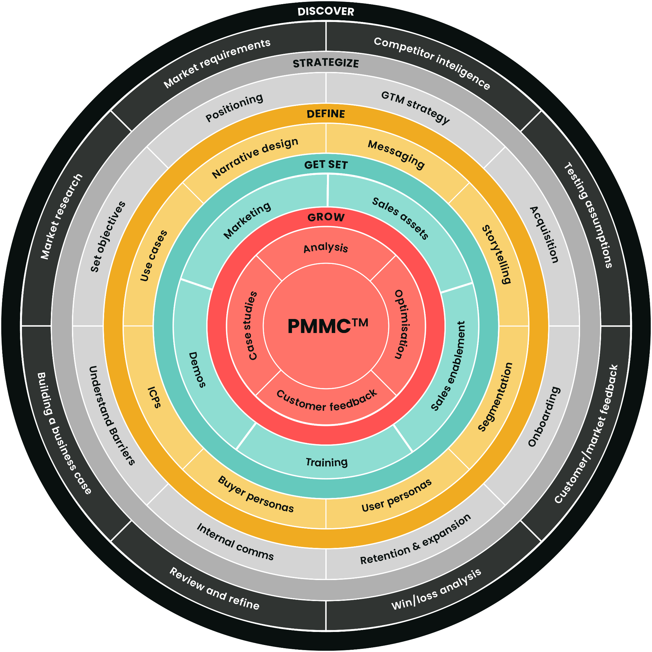

In the grids below we’ve broken down the different metrics that you might choose to track within each key phase.

The phases that we outline in the framework cycle continuously. There will be some metrics that will pop up over multiple phases because they should be tracked continually and many require several iterations before you can truly derive meaning from the numbers.

The last grid in this section breaks down the metrics that you should consider tracking on a monthly basis throughout the year, regardless of the stage of the work cycle you happen to be in.

And of course, bear in mind that this is just a guide and the metrics you choose to track will depend on your industry, product, company size, and overarching company goals. We’ll go into how to tie your metrics to your goals later in the framework.

Discover

| **Metric** | **Why this metric?** |
| --- | --- |
| **Win rate** | Analyzing win/loss data is an important part of the competitive intel section of this phase. |
| **NPS (Net Promoter Score)** | This forms part of your customer and market research work which is an ongoing part of the PMM role. |
| **Google Trends** | You can choose to analyze how many times your company was googled versus your competitors’ using Google Trends as part of your competitive intel piece. |
| **Brand awareness** | This is an important part of your customer and market research work. You should aim to get a gauge on brand awareness when you first step into a PMM role so you know what you’re working with. |
| **Customer lifetime value** | It’s important to assess your customer lifetime value as part of your initial market research piece and in tandem with NPS and win rate. |

Strategize

| **Metric** | **Why this metric?** |
| --- | --- |
| **Van Westendorp price sensitivity meter** | The four questions that form the Van Westerndorp price sensitivity meter will help you establish product-market fit and find out what your customers are willing to pay, an important part of your GTM strategy. |
| **Customer interviews/beta testing** | You’ll want to gather some numbers around how your beta testers feel about the product you’re about to launch as part of your GTM piece. You’ll need to recruit customers, run the test, and analyze the results. This data will help you set a realistic launch date. |
| **Market share** | If one of the goals of your GTM strategy is to increase your market share then you’ll need to know what percentage of the market you currently own and where your potential for growth is. |
| **Asset utilization** | Analyzing asset utilization is an important part of your SE strategy and overall GTM strategy. You need to know which assets are used the most and are the most effective in order to prepare sales reps ahead of a launch. |
| **Sales confidence** | Prior to launch, it’s crucial to measure sales confidence to see how prepared your sales team feels to sell new products and features. Make sure you do this a few months ahead of your launch so that you have enough time to act on the data you get back. |
| **Annual recurring revenue** | Annual recurring revenue is a metric that you will be continually tracking throughout the five stages. You will need to be able to show whether the needle has moved in this metric a few months after launch compared to prior to launch. |

Define

| **Metric** | **Why this metric?** |
| --- | --- |
| **Conversion rate in target segment** | The four questions that form the Van Westerndorp price sensitivity meter will help you establish product-market fit and find out what your customers are willing to pay, an important part of your GTM strategy. |
| **Use cases and case studies** | Work out how many successful customer stories you have for your target segments. How can you increase this number and show potential customers the real-world value you bring? |
| **Sign-up surveys** | Sign-up surveys will help you gather otherwise hard-to-find info on your customers and better define the preferences and business value of each segment you serve. |

Get set

| **Metric** | **Why this metric?** |
| --- | --- |
| **Sales confidence survey (2nd iteration)** | As you get closer to your launch date, you should keep checking in with your sales team and see how confident they are with their materials. This can be incorporated into your pre-training surveys so you can track how confidence improved before and after training. |
| **Pre-training sales surveys** | This will help you structure and focus your sales training on specific products and features ahead of launch. |
| **Customer acquisition cost (CAC)** | CAC is a metric that PMM and marketing should both own. You should always be tracking this metric but pay particular attention to how new product or feature launches impact your numbers here. |
| **Annual recurring revenue and monthly recurring revenue.** | As you’ll see, these metrics should be tracked monthly throughout the year. During the get set phase of work, you should know whether you’re charging for a new product or feature separately and how this might affect your revenue numbers. |

Grow

| **Metric** | **Why this metric?** |
| --- | --- |
| **Customer lifetime value (CLV)** | This is an important metric to examine during the analysis stage of your work. You should always aim to increase the average lifetime value of your customers and use your best customers as the basis for your case studies. |
| **Customer acquisition cost (CAC)** | As we said before, this metric should be tracked pretty much continually. CAC should be looked at in conjunction with cost to serve and CLV. You should always be aware of how much it costs to acquire a new customer but it’s especially important to analyze and reduce this number while you’re finding ways to grow your business and increase revenue. |
| **Cost to serve** | Cost to serve should be viewed alongside CLV and CAC. When you’re analyzing you should look into the cost of getting the product into the customer’s hands and ways to reduce this. |
| **NPS (Net Promoter Score)** | Gathering customer feedback is an important part of the growth stage. |
| **Case studies** | Case studies are a vitally important part of the growth stage. They’re how you show rather than tell your audience what you can really do. The strongest case studies will be metrics-driven and quantify how you solved a problem. You can also choose to track case studies as a metric in themselves. For example, you could aim to increase the number of case studies for your most profitable and loyal customer segments by 20% over the next quarter. |
| **Retention** | As part of your analysis work that is essential for growth, you should examine how good the upsell and cross-sell growth is across product lines and solutions as a means to keep existing customers engaged. |
| **New markets and industries** | Once you have a solid foundation with your existing customer segments and marketplace, it may be time to talk to your analysts and find new markets and industries to venture into. |
| **New buyer persona / audience growth** | Once you’ve identified new marketplaces that care about your offering, you’ll need to create new buyer personas and find ways to reach that new audience. |

Monthly Metrics

| **Metric** | **Why this metric?** |
| --- | --- |
| **Annual recurring revenue (ARR)** | ARR is a metric that you always want to move the needle on and shows how all your efforts, regardless of the stage you’re in, are contributing to the bottom line. By examining a combination of ARR and MRR you can tell if you’re on track to hit your revenue targets for the end of the year. |
| **Monthly recurring revenue (MRR)** | You should look at MRR so that you can keep a close eye on the trends throughout the year that affect your revenue and plan your expenditure accordingly. |
| **Churn rate** | Churn rate is normally looked at on a monthly basis and shows you how many customers from each cohort you’re losing and how much revenue you’re losing throughout the year. |
| **Sign-up to subscriber conversion rate** | This metric is normally looked at on a monthly basis. You need to calculate which customer cohorts convert the best for you and then plan your marketing strategies accordingly. |

How to tie metrics to your objectives

In the table below we’ve put together some examples of the types of OKRs PMMs are often judged against, alongside the metric or KPI that you’d need to track. Key Performance Indicators should be measurable and communicate to your team and company leadership how you can improve your performance in the future.

Remember, the exact objectives and percentage increases you’ll aim for as a PMM will vary according to your particular industry, product, and the maturity of the company you work for. Once you know your particular objectives and KPIs, your aim is to visualize them on a dashboard that tells the story of how your function makes an undeniable impact on the bottom line.

| **Example objectives** | **The KPIs you could create** |
| --- | --- |
| **Priority for all internal stakeholders - we need to connect our initiatives with their success.** | If this was your objective you’d need to break down your KPIs for sales, product, and marketing.   * Sales - average deal size, increase SQLs in the pipeline * Marketing: Leads/MQLs, CAC, LTV * Product: Product usage, adoption, churn, retention. |
| **Become more market and data-driven and persona-led. Adapt to market trends to drive momentum.** | With this objective, you’d need to create KPIs that were based on a mixture of both quantitative data relating to your marketplace, and qualitative data relating to your customer personas. These might look like:   * Increase market share by x% * Identify your most powerful customer segments and focus on increasing SQLs within them. * Aim to create x number of buyer personas within the next quarter. |
| **Support the buyer’s journey and increase product adoption.** | With this objective, you should focus on the awareness, consideration, and decision stages of the buyer journey. You could track:   * Brand awareness, recall, and recognition through Google trends and customer surveys. * Increase in asset usage, specifically related to the consideration stage of the buyer process. * Increase in active users. * Increase in feature adoption. |
| **Drive growth and retention by increasing active users to 60% by the end of the year.** | With this objective, your KPIs should track the rate of engagement and customer satisfaction. You’ll get the data you need from your CRM system and from qualitative research directly with customers. You should track:   * An increase in active users * Improvement in time to value * An increase in feature adoption * Your net promoter score * Your retention |
| **Increase sign-up rate from product pages by 10% over the next quarter.** | With this objective, you’re obviously going to keep your eye on the main sign-up rate KPI that you’re trying to move the needle on but you’re also going to have to set some KPIs around content and work closely with marketing. You could look at:   * Increasing the number of customer quotes and reviews on page. * Increasing mobile conversions. * Utilizing your customer interviews to find out what works for them on page. Then track how often you’re using those elements and to what effect. |
| **Increase win rate by 5% by the end of the quarter.** | Any objective around win rate will undoubtedly mean you need to work very closely with sales in order to see success. The metrics you could share with sales for this objective could be:   * The no. of deals closed on a monthly basis. * Time to close * Average deal size. * Sales confidence |
| **Reduce churn by 15% over the next two quarters.** | There are lots of aspects of your service or product that could be contributing to churn but you’ll definitely want to track:   * Your current churn rate * Customer satisfaction through NPS |
| **Improve time to close by decreasing the average TTC by three months.** | Any objective related to time to close will require you to take a close look at the performance of your sales team, the enablement materials they’re currently using as well as when customers usually convert along the journey. To track progress with this objective you should look at:   * Your current TTC * The average performance of your sales reps * Sales confidence * Asset utilization |

We hope that you’ve found this framework on OKRs and KPIs helpful. Remember, when it comes to OKR success consistency is key – you won’t see the results you’re after if the goalposts are always moving. In general, try not to pick more than five KPIs for each OKR you’re working towards, and always make sure that your metrics are a true measure of success for your stakeholders.